COVID-19
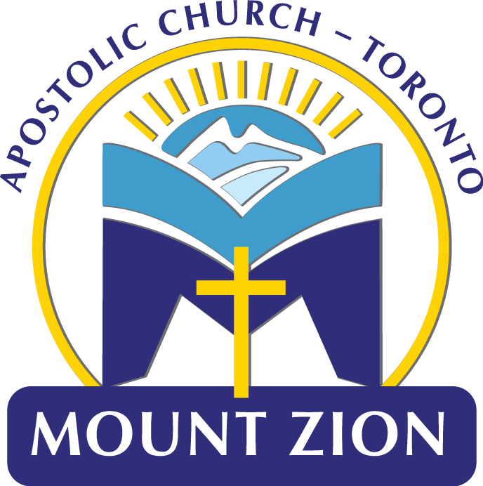
HEALTH DISCLOSURE DECLARATION
(1 form per family)
Prior to entering 30 Pemican Court, please consider the health and safety of others.
Access to the building will not be granted for anyone who has either not completed this form or has been unable to check all of the above 4 criteria.

Date:
Person 1
Name: Phone#:
I confirm the following statements to be true (check all that apply):
- I have not travelled anywhere outside of Canada, or been in contact with anyone who has travelled outside of Canada, in the last 14 days.
- I have not experienced any of the following symptoms in the last 14 days: fever, dry cough, shortness of breath, or difficulty breathing.
- I have not knowingly come into contact with anyone experiencing any of the following symptoms in the last 14 days: fever, dry cough, shortness of breath, or difficulty breathing.
- I have not knowingly come into contact with anyone with a presumptive or confirmed COVID-19 diagnosis in the last 14 days.

Person 2 Name:
I confirm the following statements to be true (check all that apply):
- I have not travelled anywhere outside of Canada, or been in contact with anyone who has travelled outside of Canada, in the last 14 days.
- I have not experienced any of the following symptoms in the last 14 days: fever, dry cough, shortness of breath, or difficulty breathing.
- I have not knowingly come into contact with anyone experiencing any of the following symptoms in the last 14 days: fever, dry cough, shortness of breath, or difficulty breathing.
- I have not knowingly come into contact with anyone with a presumptive or confirmed COVID-19 diagnosis in the last 14 days.

Person 3 Name:
I confirm the following statements to be true (check all that apply):
- I have not travelled anywhere outside of Canada, or been in contact with anyone who has travelled outside of Canada, in the last 14 days.
- I have not experienced any of the following symptoms in the last 14 days: fever, dry cough, shortness of breath, or difficulty breathing.
- I have not knowingly come into contact with anyone experiencing any of the following symptoms in the last 14 days: fever, dry cough, shortness of breath, or difficulty breathing.
- I have not knowingly come into contact with anyone with a presumptive or confirmed COVID-19 diagnosis in the last 14 days.

Person 4 Name:
I confirm the following statements to be true (check all that apply):
- I have not travelled anywhere outside of Canada, or been in contact with anyone who has travelled outside of Canada, in the last 14 days.
- I have not experienced any of the following symptoms in the last 14 days: fever, dry cough, shortness of breath, or difficulty breathing.
- I have not knowingly come into contact with anyone experiencing any of the following symptoms in the last 14 days: fever, dry cough, shortness of breath, or difficulty breathing.
- I have not knowingly come into contact with anyone with a presumptive or confirmed COVID-19 diagnosis in the last 14 days.

Mount Zion Apostolic Church - Toronto has taken steps to ensure the requirements as set out by the Provincial Government of Canada are adhered to. Please ensure that the proper protocols are followed (i.e., maintain physical distancing, practice proper sanitization of hands, wear mask, etc. Thank you for your cooperation!

